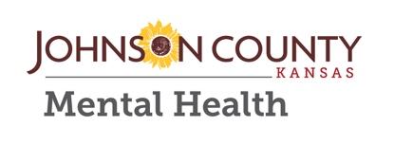
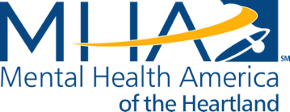
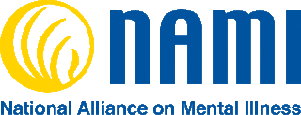
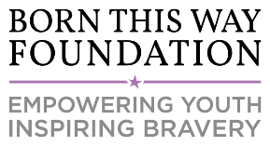

MEDIA ADVISORY

Lady Gaga’s Born This Way Foundation, NAMI Johnson County, Mental Health America of the Heartland, and Johnson County Mental Health Host Conversation about Youth Mental Wellness in Kansas City

Lady Gaga’s Born This Way Foundation, NAMI Johnson County, Mental Health America of the Heartland, and Johnson County Mental Health will co-host a discussion focused on how parents and other caring adults can help support our young people's mental wellness.

The event will highlight the findings of Born This Way Foundation’s recently released survey, Kind Communities: A Bridge to Youth Mental Wellness, followed by a parent testimonial by Dr. Arkin, a panel discussion and Q + A. Attendees will also have the opportunity to learn more about local mental wellness resources in their community and will be eligible to win a pair of tickets to Lady Gaga's Joanne World Tour concert on Wednesday, November 15th at the Sprint Center.

The event is part of Born This Way Foundation’s Channel Kindness Tour – a series of activations, youth-led service events, and community gatherings that are organized to coincide with Lady Gaga’s Joanne World Tour.

What: Mental wellness information fair + discussion featuring Born This Way Foundation, mental health experts, and community members

When: Tuesday November 14, 2017

Time: 5:30 p.m. – 8:00 p.m. (Speaking program begins at 6:30 p.m.)

Where: Cleveland University
10850 Lowell Ave, Overland Park, KS 66210

----
Media contact:
Shadille Estepan
Shadille@BornThisWay.Foundation

